The diagram reproduced below will help to give a more detailed explanation of the greenhouse effect. First of all, we need to talk about radiation. Radiation is a form of wave motion and we can therefore get a better idea of what it is by analogy with water waves, but the analogy is only partial. Like all waves, radiation has a wavelength and a frequency (see diagram), the frequency being how fast the wave moves up and down, from peak to peak (or trough to trough, makes no difference) and the wavelength the distance from peak to peak. However, unlike water waves, all forms of radiation travel at the same velocity, namely the speed of light, and more strangely, while water is the medium for water waves (and air the medium for sound waves) there is no substantial medium which radiation ‘disturbs’. The wavelength, and hence the frequency as these are proportional, determines different kinds of radiation, which are said to form a spectrum, or distribution, from short wavelength gamma radiation to long wavelength radio waves.
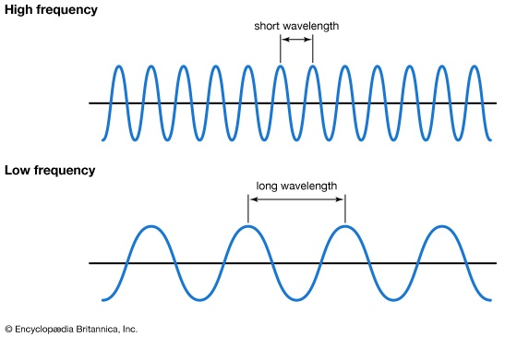
The sun emits radiation at lots of different wavelengths; it emits radiation along much of the spectrum. Visible light, for instance, is one kind (or kinds), as are the dangerous short wavelength ultraviolet radiation, much of which is absorbed by the ozone in the atmosphere. How does radiation heat things up?
According to the kinetic theory of heat, the basic idea of which is that heat is a form of atomic or molecular motion, an object (something which is not radiation) becomes hotter when its molecular and atomic constituents start to move more quickly. For example, to say that a sample of water is becoming hotter means, according the kinetic theory of heat, that the water molecules are moving around faster than they did before. One way that the water could acquire heat is by absorbing radiant energy from the Sun; that is to say, individual water molecules absorb incident radiation and this absorbed energy becomes manifest as (increased) motion. Water molecules are made up of three atoms: one oxygen atom and two hydrogens, represented by the red and white balls in the diagram. Imagine two these colliding, with one initially going faster than the other. Since they have the same mass, the respective velocities after the collision will depend on the initial velocities. But the outcome will also depend on the way in which the molecules vibrate. As we can see from the diagrams, the bonds which connect the oxygen to the hydrogen atoms are ‘flexible’ and can vibrate in certain ways, or modes as these are called. If one of the molecules is vibrating much more vigorously in one or more of these modes, then we might suppose that some of this energy will be transmitted to the other molecule, and we would be right. Energy interaction can occur via translation, namely in virtue of the motion of the molecule as a whole, via vibration, and also, though this is not represented, by rotation.

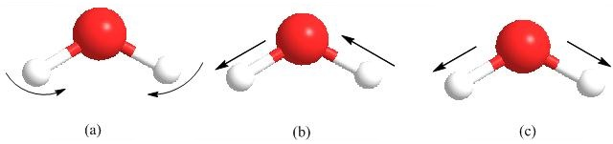

Greenhouse gases heat up the Earth because they absorb radiation, which increases their vibrational energy and which then gets transformed into heat energy via collisions with other molecules. It is, however, only those vibration modes that are asymmetric, such as (b) above, which absorb (infrared) radiation. I will now explain why this is, leaving out the technicalities. All atoms are composed of negatively-charged electrons, positively-charged protons and neutrons which bear no charge. Atoms form molecules, in the right circumstances, because this process lowers their (chemical) energy and so makes them more stable. For instance, when ignited, hydrogen will burn in oxygen, forming water molecules. These are more stable than their atomic constituents, according to valence theory (which is that part of chemistry which explains why atoms react), because they ‘share’ their electrons. Thus the oxygen-hydrogen bond comprises two shared electrons, one each from either atom, which are able to occupy a molecular orbital which has lower energy than either of the atomic orbitals available in the atoms. However, the sharing is a little unequal: both the electrons making up the bond are pulled towards the oxygen atom because it has a greater concentration of positive charges in its nucleus. This means that the molecule is polarized: it does not have a uniform charge density and is slightly more negative in the region of the oxygen atom and more positive near the hydrogens; hence it has a dipole moment. I am not able to explain what a dipole moment is without using some mathematics, so I will simply state its significance, which is this: only molecules that vibrate asymmetrically, and therefore have dipole moment which changes, can absorb heat radiation at the wavelengths radiated back from the Earth’s surface. This is because a changing dipole moment gives rise to an electric field and it is this which interacts with the electric field of the radiation. When the later is of the right ‘size’ it stimulates the molecule to vibrate more vigorously, and this, as we have seen, heats up its surroundings.
It is fortunate that the gases that can absorb radiation only absorb some of it. This is because molecular bonds are not allowed (according to quantum mechanics) to vibrate at any frequency whatsoever. If they could, then there would be no restrictions on the kind of radiation they could absorb, any wavelength would do. That would mean that the atmosphere would have already heated up to a degree that the oceans would have boiled off, and the Earth would resemble Venus - no life as we know it, anywhere. It turns out that the bonds which hold greenhouse gas molecules together can only vibrate at certain frequencies. These are quantized and so can be represented as integers, like 0, 1, 2, etc., with 0.5, 1.3, etc., being forbidden. So for a water molecule to absorb radiation to climb from state 1 to state 2, only radiation that corresponds to that energy difference can effect the transition. This is the case for all greenhouse gases, though they absorb energy at different regions of the spectrum. So now we have an explanation of why adding more greenhouse gases to the atmosphere heats up the Earth. These gases absorb more of the radiation emitted for the Earth’s surface, which otherwise would have travelled into space and away from the Earth. This radiation is thus trapped by the greenhouse gases, and there is no alternative but that it heats up the Earth, and this process will carry on as more and more greenhouse gases are produced.

